**Hotel Room Pricing In The Indian Market**

1. Introduction:

Tourism has now become a significant industry in India. It is a sunrise industry, an employment generator, a significant source of foreign exchange for the country. Tourism in India is the third largest foreign exchange earner of the country. The booming tourism industry has had a cascading effect on the hospitality sector with an increase in the occupancy ratios and average room rates.As per world travel and tourism Council (WTTC), India is one of the favorite tourist destinations from the year 2009 and will continue to be one of the favorite till 2018. Further, the Travel and Tourism Competitiveness Report by World Economic Forum, has ranked India at the sixth place in tourism and hospitality.

Hotels are an important component of the tourism product. They contribute to the overall tourism experience through the standards of facilities and services offered by them. With the aim of providing contemporary standards of facilities and services available in the hotels, the Ministry of Tourism has formulated a voluntary scheme for classification of operational hotels which will be applicable to the following categories: Star Category Hotels: 5 Star Deluxe, 5 Star, 4 Star, 3 Star, 2 Star & 1 Star Heritage Category Hotels: Heritage Grand, Heritage Classic & Heritage Basic

This paper addresses the following issues concerning the “room rents” with respect to the hotel industry engaged in tourism industry in India. The first issue concerns the pricing strategies employed by hotels serving the tourists. In this paper, we investigate whether the hotel industry charges the tourists more in case the city is a tourist destination or if the hotel is nearer to the hotel ? We evaluate whether hotels extract a “price of a tourist destination and distance from airport” by charging higher prices for hotel rooms in more feasible locations in tourist destinations?

2. Overview of the Study

Our field study concerns the room rents of different hotels across various cities in India.The hotel industry in India thrives largely due to the growth in tourism and travel. Due to the increase in tourism with rising foreign and domestic tourists, hotel sector is bound to grow. There is an emergence of budget hotels in India to cater to the majority of the population who seek affordable stay. In this study, we compare the prices of hotel rooms based on various factors This setting provides us an excellent platform for measuring the “price of heritage”. We empirically study how the view from the room influences the room prices. Our regression analysis reveals that the Hilton hotel prices

rooms with otherwise practically identical interiors differently, depending on the listed below. The room rent ranges from lowest being Rs. 299 to Rs. 322500 being the most expensive. Once again, our analysis of hotel room prices indicates a significant “price of Stay ” depending upon multiple factors.

3. An empirical field study of hotel room rents in India

3.1 Overview

Hotels are not altogether a new idea in India. From ancient times, we find engrossing account of widespread travel across the vast region. There are many religious and historical references to dharmashalas, musafirkhanas, sarais, taverns and hotels in India as early as the 16th and 17th century. In the early eighteenth century, there were plenty of taverns in India with fashionable names like Portuguese George's, Parsee George's etc. While some of these taverns may have conformed to the concept of western style hotel, it is doubtful that many others did. Western style residential hotels are of comparatively recent origin in India.

The twentieth century constitutes a turning point in the history of the hotel industry in India. There was accelerated growth in industry with the rise of groups such as the Taj Group, the Oberoi Group and the Welcome Group (ITC hotels). With emphasis on economic growth in the post-independence period came the recognition of the basic strengths, the variety and benefits of promoting tourism in India. Keeping the same in mind the primary aim of this study is to examine the general tariff structure in Indian hotels.

*HYPOTHESIS:*

*H1:* *The prices of hotel rooms at tourist destinations which are comparatively more feasible from the airports and having a greater star rating are higher than the prices at the hotels which lack these features.*

3.2 Data

India is a large market for travel and tourism. It offers a diverse portfolio of niche tourism products - cruises, adventure, medical, wellness, sports, MICE, eco-tourism, film, rural and religious tourism. India has been recognised as a destination for spiritual tourism for domestic and international tourists.

Total contribution by travel and tourism sector to India’s GDP is expected to increase from US$ 136.3 billion in 2015 to US$ 275.2 billion in 2025. Travel and tourism is the third largest foreign exchange earner for India. A sum of US$ 1.76 billion was earned under foreign exchange through tourism during the month of September 2016.

The launch of several branding and marketing initiatives by the Government of India such as Incredible India! and Athiti Devo Bhava have provided a focused impetus to growth. The Indian government has also released a fresh category of visa - the medical visa or M visa, to encourage medical tourism in the country.

The Government has also been making serious efforts to boost investments in tourism sector. In the hotel and tourism sector, 100 per cent FDI is allowed through the automatic route. A five-year tax holiday has been offered for 2, 3 and 4 star category hotels located around UNESCO World Heritage sites (except Delhi and Mumbai). The investment in tourism sector is expected to be US$ 12.4 billion in the 12th Five Year Plan; of these, private investments are likely to total US$ 9.2 billion.

The data was collected from [www.hotels.in](http://www.hotels.in) in October 2016.

The column wise description of variables taken into consideration for the hypothesis testing.

**CityName** : There are around 42 different cities across the subcontinent for which the data was collected.

**IsTouristDestination**: It is a dummy variable which is set to 1 in case the city into consideration is a tourist destination and 0 in case it isn’t a tourist destination. As tourist destinations contribute maximum to the GDP and foreign exchange of the country, it is quite possible that the cities which are tourist destinations and attract tourists charge higher for the room rents compared to the cities which are not tourist destinations especially during the peak times of the year like the Christmas and New Years in Goa or the months of Feburary in mountain ranges of Himalaya or the Dushera time in Mysore.

**Star Rating**: In India, the Ministry of Tourism has formulated a scheme for classification of operational hotels using a “Star” rating. Hotels are rated as either 5 Star, 4 Star, 3 Star, 2 Star or 1 Star. Accordingly, we classified the hotels in our dataset using their star rating. The reason for doing this is that the star rating of a hotel has a direct, strongly positive correlation with the price of its hotel rooms. Therefore, it is important to control for rent variation because of the star rating. We used the variable to denote the star rating of each hotel in each city .

**Airport**: It is possible that hotels located close to the airport are able to charge a higher room rent for the greater convenience and easy access for the tourists.The data was recorded for the distance between a given hotel and the closest airport. We used the variables and to denote the distance of hotel in city from the closest airport and train station respectively. Also there are a few cities which themselves do not have an airport but can be reached via road from the airport in the nearby city. Also in cities like Goa the tourists are more interested to visit the coastal areas but the Goa airport is located in the central city.

**Population**: Its a number which represents the population of the city according to the census survey conducted in 2011.

There are also other factors like IsMetroCity, IsWeekend , IsNewYearEve, HasSwimmingPool, HasWifi which are all dummy variables and 1 incase the conditions are true and 0 in case they are not. These factors did not seem to play a very impressive role on the room rents.

HotelAddress and HotelDesciption are text variables and vary for each hotel in each city.

3.3 Model

In order to test Hypothesis, we proposed the following model:

We established the effect of heritage view on the rent of a hotel room with the simplest model. We regressed on , the interaction between the listed variables .We estimated model, using linear least squares. If there was a rent difference in the market, we expected to find the coefficients of to be positive.

3.4 Results

We found empirical support for H1. The average room rents in tourist destinations was higher than the average room rent in non tourist destinations. Similarly average price for the hotel room with 5 stars was higher than the price of hotel room with 4 stars and so on. The regression analysis using Ordinary Least Squares yielded was room rent for higher star rating and tourist destinations was higher than the rent of the others. On running the t test on the linear fit the pvalue was found to be **< 2.2e-16.**

4. Conclusion

This paper was motivated by the need for research that could improve our understanding of how the different factors associated with a hotel influence the room rental strategies in the hotel industry. The unique contribution of this paper is that we investigated the higher price is charged by hotels to tourists who travel to tourist destinations with the convenience of air transport. We found that tourists visiting tourist destinations and having a stay at high rated hotel rooms end up paying a higher price.

5. References:

* [**https://www.ibef.org/industry/indian-tourism-and-hospitality-industry-analysis-presentation**](https://www.ibef.org/industry/indian-tourism-and-hospitality-industry-analysis-presentation)**.**
* **For the data set -** [**http://www.hotels.in/**](http://www.hotels.in/)
* [**https://docs.google.com/document/d/1_Bq_NhLK8wEHYx43cKXOBqdvxzRuuc1DqdxaXRsaR84/edit**](https://docs.google.com/document/d/1_Bq_NhLK8wEHYx43cKXOBqdvxzRuuc1DqdxaXRsaR84/edit)
* **Sample reports:** [**https://drive.google.com/file/d/0B3oXSJHLqZqXZkNyTWxyalB3cVU/view**](https://drive.google.com/file/d/0B3oXSJHLqZqXZkNyTWxyalB3cVU/view)
* [**https://drive.google.com/file/d/0B3oXSJHLqZqXbElENmhGZW1SRFE/view**](https://drive.google.com/file/d/0B3oXSJHLqZqXbElENmhGZW1SRFE/view)
* [**http://tourism.gov.in/**](http://tourism.gov.in/)

**Table 1: Summary Statistics of the Hotel Room Rent Study**

**IsTouristDestination mean room rent SD**

0 4111.003 3037.830

1 6066.024 8483.476

**StarRating mean room rent SD**

0.0 7237.125 6303.4146

1.0 686.625 202.3617

2.0 2783.166 1805.5577

2.5 2520.816 1727.1692

3.0 3694.811 2864.0726

3.2 15937.500 8561.4898

3.3 2841.062 1216.5358

3.4 23437.500 9688.1279

3.5 4843.346 3141.5313

3.6 7769.500 971.2188

3.7 6701.958 2049.8067

3.8 5400.062 1788.0045

3.9 13062.750 12445.5317

4.0 6393.105 4397.0254

4.1 19075.000 9281.4097

4.3 7423.125 1481.0929

4.4 5563.500 371.5962

4.5 8699.920 9602.0364

4.7 10125.000 566.9467

4.8 46752.812 5069.4339

5.0 12398.221 17098.6651

**Table 2: Regression Analysis in the Study Hotel Room Rents in India**

**β Std.Error t - statistics**

(Intercept) 27656 50788 0.545

IsTd1 30241 4504 6.714

StarRating1 -52404 87621 -0.598

StarRating2 -22980 51786 -0.444

StarRating2.5 -23488 51403 -0.457

StarRating3 2338 50728 0.046

StarRating3.2 69603 87621 0.794

StarRating3.3 -35169 71542 -0.492

StarRating3.4 129603 87621 1.479

StarRating3.5 1426 50906 0.028

StarRating3.6 4259 87621 0.049

StarRating3.7 5799 65326 0.089

StarRating3.8 15545 71684 0.217

StarRating3.9 61726 61998 0.996

StarRating4 24026 50841 0.473

StarRating4.1 94703 65309 1.450

StarRating4.3 31729 71684 0.443

StarRating4.4 16852 87737 0.192

StarRating4.5 31509 51807 0.608

StarRating4.7 53344 87737 0.608

StarRating4.8 316126 71542 4.419

StarRating5 70114 50950 1.376

Hotels in India:

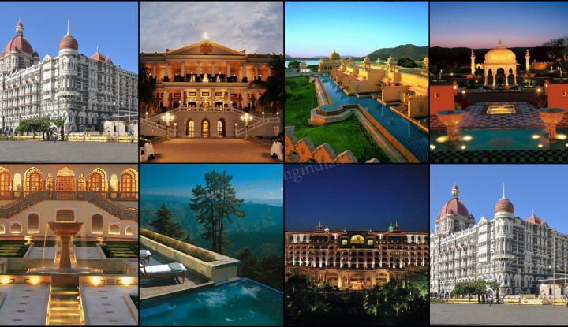

View of Hotel Rooms:

1. Hilton Hotel room, Jaipur

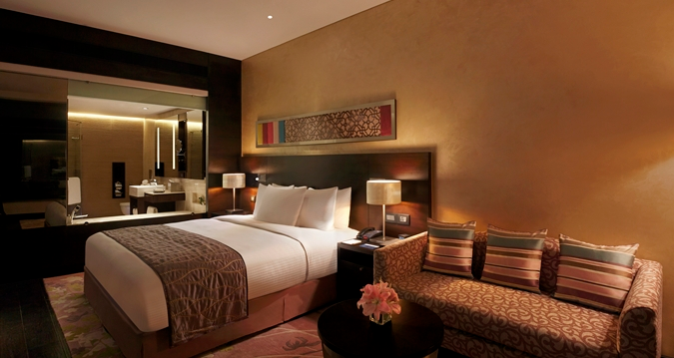

2. Oberoi Udaivilas hotel room, Udaipur

